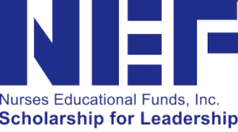

DONATE BY MAIL

Please print this form and mail it with your check to:

Nurses Educational Funds, Inc.
137 Montague Street
Brooklyn, NY 11201

First Name(s):_______________________________________________________

Last Name: _________________________________________________________

Address: ___________________________________________________________

City: ____________________________________ State: _______ Zip: _________

Email: _____________________________________________________________

Phone: __________________________________ ⬜ Home ⬜ Mobile

Does your company match? ⬜ Yes ⬜ No / not applicable

If yes, company name: ________________________________________________

